Charter Status, Family Structure, and ACT Performance
ACT Scores by Charter Status and Family Structure

Abstract
The study examined the relationship between charter status, family structure, and the average ACT scores of 7,227 U.S. public high schools during the 2016–17 period. The dataset covered 20 states and included 170 charter schools. On average, charter schools scored 1.31 points lower than non-charter schools. After accounting for the proportion of children living in families with two married parents (the marriage percentage), the gap narrowed to 0.44 points. When all five socioeconomic factors were included, the difference fell to 0.17 points and was no longer statistically significant. Although the marriage percentage was a powerful predictor on its own, it added little to the full model. The link between the marriage percentage and ACT scores was weaker for charter schools, and this difference stayed significant in the sensitivity analyses. Adjusting for socioeconomic differences explained a large part of the observed gap between charter and non-charter schools, although causality cannot be established from this analysis.

Introduction
Average test scores provide a simple way to compare charter and non-charter schools, yet differences in student populations may cause score gaps due to variations in family income and neighborhood conditions.
The objective of the project was to determine the extent to which the charter gap persisted after accounting for the characteristics of the communities in which the schools are located. The analysis focused on family structure, specifically the proportion of children living with both parents. The study examined whether this factor and charter status were linked to average ACT scores at the high schools and whether the relationship with family structure varied by school type.

Theoretical Background
The Coleman Report showed that family background accounted for a greater proportion of the differences in student achievement than school-related resources such as spending, class size, or teacher qualifications (Coleman et al., 1966). Sirin's (2005) examination of 74 samples likewise found a medium-to-strong link between socioeconomic status and achievement. The strength of this association depended on whether the analyses were carried out at the level of individual students or at the level of school averages; the present study uses school averages, which is a point worth noting.
McLanahan, Tach, and Schneider (2013) examined studies that sought to separate the effects of a father's absence from other factors, such as lower income, and found that negative effects persisted, albeit smaller than in simpler comparisons. It was therefore expected that the marriage rate would show a stronger association with ACT scores when considered on its own than when other socioeconomic measures were considered.
The number of students in charter schools can be different from that in other public schools. In the fall of 2021, 31 percent of students in charter schools attended high-poverty schools, compared with 21 percent of students in traditional public schools (NCES, 2023). When Raymond et al. (2023) compared students in charter schools with demographically similar peers living in surrounding areas, they found only small average gains for charter school students; larger gains were observed among students from low-income families and those in urban charter schools. Even though the studies involve different years and groups for comparison, they highlight the need to consider factors beyond simple comparisons of schools' average performance.
The importance of the level of ACT participation should also be noted. In the case of the class of 2017, 17 states administered the test to all graduates, whereas in other states, it was mainly college-bound students who took the test (ACT, 2017). To address this, the analysis compares schools within the same state. Even though this method accounts for differences between states, it does not allow for isolating the extent to which these differences are attributable to variation in test participation.

Methodology
The average ACT score for each school and the SAT averages converted to the ACT scale, together with the socioeconomic data for the surrounding census tract, were obtained from EdGap (Fischer, n.d.), and the 2016–17 NCES Common Core of Data (CCD) was used to identify the high schools and to find out their charter status (NCES, n.d.).
At first, missing values were introduced when ACT scores were less than 1 or lunch shares were negative. Only data from high schools were retained, and three schools with no valid ACT scores were excluded. The missing values for the socioeconomic variables were filled in using scikit-learn's IterativeImputer. As a result, 7,227 high schools from 20 states were left. The CCD showed that 170 of them were charter schools, 6,858 were non-charter, and 199 were not applicable. Almost all the schools in the 'not applicable' category were in Kentucky, a state that did not have a charter law at that time; this group was regarded as non-charter, resulting in a total of 170 charter schools and 7,057 non-charter schools.
The most important variable in this analysis is percent_married, which measures the proportion of children in the census tract adjacent to a school whose parents are in married-couple families (the marriage percentage). The analysis also accounted for the fraction of students eligible for free or reduced-price lunch, along with three other indicators for the census tract: the proportion of adults with a college degree, the unemployment rate, and the median household income.
The analysis was conducted in Python using pandas, SciPy, statsmodels, scikit-learn, and seaborn. The following steps were undertaken:
- The Welch t-tests were applied to compare ACT scores and the percentage marrying between charter and non-charter schools, since this method accounts for unequal variances and was suitable given the different group sizes and score distributions.
- The regressions initially used the marriage percentage, charter status, and both variables together to predict ACT scores; furthermore, a quadratic term for the marriage percentage and an interaction model that allowed the slope to vary by school type were also examined.
- The complete model accounted for charter status and all five socioeconomic variables, whereas the reduced model retained only charter status, unemployment, college education, and lunch eligibility. The two models were compared using ANOVA, R² values, and mean absolute error (MAE). A correlation matrix and variance inflation factors (VIFs) were used to examine the overlap among the predictors.
- To carry out the sensitivity checks, robust standard errors were used as recommended by HC3; the 35 schools with marriage rates of exactly 0% or 100% were excluded, and state fixed effects were included in separate versions of the analysis.

Results

ACT and family structure by school type
Charter schools scored an average of 19.02 on the ACT, while non-charter schools had an average score of 20.33, a difference of 1.31 points (see Figure 1). The scores of charter schools were also more spread out; their standard deviation was 3.14 as compared to 2.48 for non-charter schools.
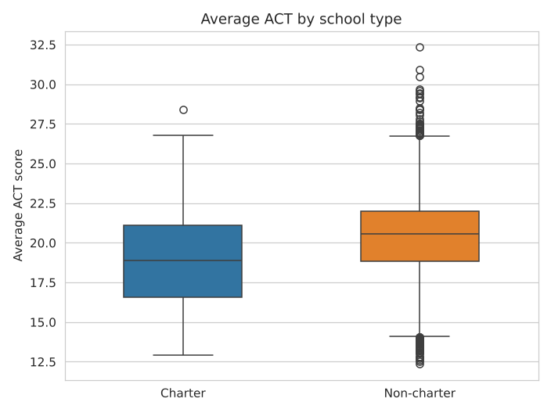
Figure 1. Average ACT scores by school type (notebook output).
The other areas too exhibited differences: 49 per cent of the children in the areas adjacent to charter schools lived in married-couple families as compared to 64 per cent of those in the areas adjacent to non-charter schools. Both the ACT gap and the difference in the proportion of such families were statistically significant (Table 1).
Average ACT | 19.02 | 20.33 | −1.31 | −5.39 | 2.2e-7 | −1.79 to −0.83
percent_married | 0.492 | 0.644 | −0.152 | −8.37 | 1.8e-14 | −0.188 to −0.116

Family structure and the charter gap
Marriage accounted for 19.3% of the variation in the ACT scores on its own. The slope was 5.77, or approximately 0.58 ACT points for every 10-point increase (t = 41.6, p < 0.001). Although the quadratic term was significant (p = 0.005), the R² value did not change much, increasing only from 0.1934 to 0.1943, and the MAE was not improved either; for this reason, I chose to keep the linear model since the extra term made only a small contribution to the fit.
The smaller the charter gap becomes, the more controls are introduced. Considering the proportion of married people, the figure drops from −1.31 to −0.44, a reduction of about two-thirds. When all five socioeconomic variables are taken into consideration, the estimate is −0.17 and no longer statistically significant. The charter status alone explains less than 1% of the variation in the scores.
Charter only | −1.31 | < 0.001 | 0.006 | 1.956
percent_married + charter | −0.44 | 0.013 | 0.194 | 1.735
Full model + charter | −0.17 | 0.158 | 0.628 | 1.145
Reduced model + charter | −0.16 | 0.173 | 0.628 | 1.146

Interaction between family structure and charter status
As shown in Figure 2, the rise in ACT scores with increasing marriage percentage is less steep for charter schools than for non-charter schools. The slope for charter schools is 3.27 and that for non-charter schools is 5.82, the difference being −2.55 (p = 0.0007). The lines fitted to the data cross each other at a marriage percentage of about 33%. At a marriage percentage of 20% the estimated difference for charter schools is +0.32 points and this is not significant (p = 0.26). When the marriage percentage is 70% the predicted charter score is 0.95 points below the non-charter score and at 80% it is 1.21 points below.
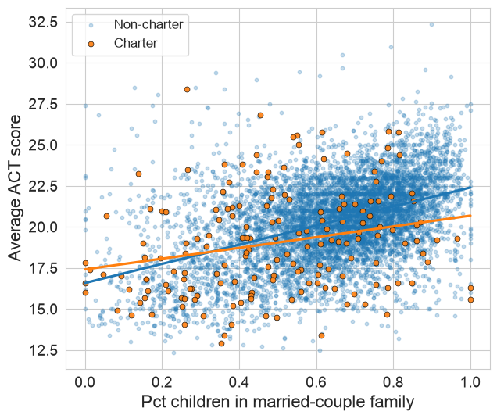
Figure 2. ACT scores and marriage percentage by school type (notebook output).

Full model
The model explained 62.8 percent of the variation in ACT scores, with lunch eligibility as the most important predictor in the standardized model. An increase of one standard deviation was associated with a loss of 1.78 ACT points, whereas there was an increase of 0.28 points in the case of having a college education and a decrease of 0.12 points when unemployed. The coefficient for the percentage of married people fell to –0.09 (p = 0.52). However, when both the percentage of people who were married and the median income were removed, there was no substantial worsening of the model's fit (ANOVA p = 0.75).
The proportion of married people overlaps with other socioeconomic indicators (see Figure 3): it correlates −0.56 with unemployment and +0.62 with median income. Simply including lunch eligibility caused the slope of the marriage rate to drop from 5.77 to 0.63. However, when all other variables were included in the model, lunch eligibility contributed only a small amount to predicting ACT scores. The VIF values were between 1.6 and 2.7, indicating no severe multicollinearity. The VIF for charter status was about 1.0, indicating little linear overlap with the other predictors.
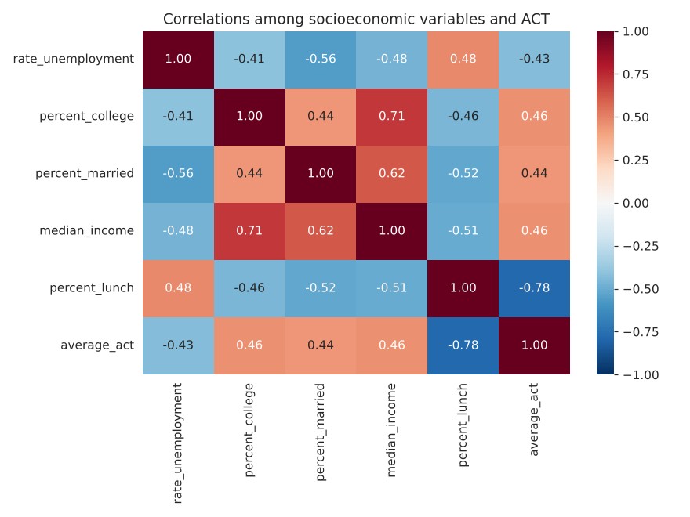
Figure 3. Correlations among ACT scores and socioeconomic measures (notebook output).

Reliability checks
Charter gap, controlling for percent_married | −0.44 (p = 0.013) | p = 0.071 | −0.35 (p = 0.15) | −0.42 (p = 0.078)
Interaction (marriage × charter) | −2.55 (p = 0.0007) | p = 0.007 | −2.20 (p = 0.026) | −2.63 (p = 0.005)
Charter gap, full model | −0.17 (p = 0.158) | p = 0.277 |  | −0.10 (p = 0.52)
The slopes continued to show significant differences across all three checks. After accounting for the percentage of people who married, the charter gap became less stable. Its p-value was 0.013 using ordinary standard errors, rose to 0.071 with robust standard errors, reached 0.15 after omitting tracts with 0% or 100% marriage rates, and was 0.078 when state fixed effects were included. The unadjusted gap within states was −1.20 points, and after adding state fixed effects, R² increased from about 0.19 to 0.30, indicating that differences between states accounted for some of the variation in the scores. However, this analysis does not make it clear how much of that can be attributed to ACT participation. In the full model, the charter gap was not statistically significant whether robust standard errors or state fixed effects were used.

Discussion
The charter gap changed significantly when socioeconomic indicators were taken into account. Although a gap still existed even when schools within the same state were compared, the full model brought the estimate down to −0.17 points. These results indicate that care should be taken when interpreting the raw gap as evidence of differences in school quality. This pattern is consistent with research on family background and academic achievement (Coleman et al., 1966; Sirin, 2005) and with NCES (2023) data showing that a larger share of charter students attends high-poverty schools.
The value obtained for the proportion of people who are married was in line with expectations. Although it was a powerful predictor on its own, it added very little when other socioeconomic indicators were considered. This expectation was based on the work of McLanahan et al. (2013), even though their study examined father absence rather than the neighborhood measure used in this study. The fact that the effect of the marriage percentage is reduced does not mean that family structure is unimportant. In this dataset, the marriage percentage is closely linked to both income and poverty, making it difficult to interpret the individual relationships between these variables and ACT scores.
A significant result was the slower slope associated with charter schools. At low levels of marriage, the model showed only a small difference between charter and traditional schools, but as marriage rates increased, a larger negative gap emerged. It is possible that charter schools do relatively well with disadvantaged students, consistent with CREDO's findings on pupils in poverty (Raymond et al., 2023). It might also be the case that students in charter schools differ from those in the surrounding areas. However, the data do not enable us to decide which of these explanations is correct.
There are bounds on the conclusions that can be reached. The data are based on empirical evidence and do not prove a causal link between charter status or family structure and ACT scores. Most socioeconomic indicators refer to the area around a school rather than to the students attending it, and charter schools may include pupils from outside those areas. The estimate of the charter slope is imprecise since there are only 170 charter schools. Furthermore, the data relate to only one school year and 20 states.

Conclusion
When all five socioeconomic factors were considered, the estimated gap between charter and non-charter schools was small and not statistically significant. Although the marriage rate had a strong association with its own scores, it contributed little to the model. The difference in slopes between charter and non-charter schools remained significant across all checks, but the data do not explain why these slopes differ.
One has to be careful about judging charter schools just on the basis of their average ACT scores, since when I included socioeconomic factors in my analysis, there was a significant change in the results between the groups; moreover, I intend to use the student-level data together with their previous test scores in order to see how much the students improve.

References
ACT, Inc. (2017). The condition of college & career readiness 2017: National. ACT, Inc. https://www.ohe.state.mn.us/pdf/ACT_CCCR_National.pdf
J. S. Coleman, E. Q. Campbell, C. J. Hobson, J. McPartland, A. M. Mood, F. D. Weinfeld, and R. L. York (1966), Equality of Educational Opportunity, published by the U.S. Government Printing Office. Summary: https://www.educationnext.org/james-coleman-and-20th-century-school-reform/
Fischer, B. (n.d.). Education inequality. In DATA 3320 course notes. Seattle University. https://bookdown.org/bfischer_su/data_3320_bookdown/edgap.html
McLanahan, S., Tach, L. and Schneider, D. (2013) 'The causal effects of father absence', Annual Review of Sociology, 39, pp. 399–427. https://doi.org/10.1146/annurev-soc-071312-145704
Public charter school enrollment, a topic covered in the Condition of Education report by the National Center for Education Statistics, which is part of the U.S. Department of Education's Institute of Education Sciences. https://nces.ed.gov/programs/coe/indicator/cgb/public-charter-enrollment
The 2016–17 edition of the Common Core of Data (CCD) [Data set], which is the survey of all public elementary and secondary schools, was supplied by the National Center for Education Statistics (n.d.) of the U.S. Department of Education. https://nces.ed.gov/ccd
Raymond, M. E., Woodworth, J. L., Lee, W. F. and Bachofer, S. (2023) In fact: III the national charter school study 2023. CREDO, Stanford University. https://ncss3.stanford.edu/wp-content/uploads/2023/06/Credo-NCSS3-ExecutiveSummary.pdf
S. R. Sirin (2005), 'Socioeconomic status and academic achievement: A meta-analytic review of research', Review of Educational Research, 75(3), pp. 417–453. https://doi.org/10.3102/00346543075003417

